DIVISIONS OF THE TOWN

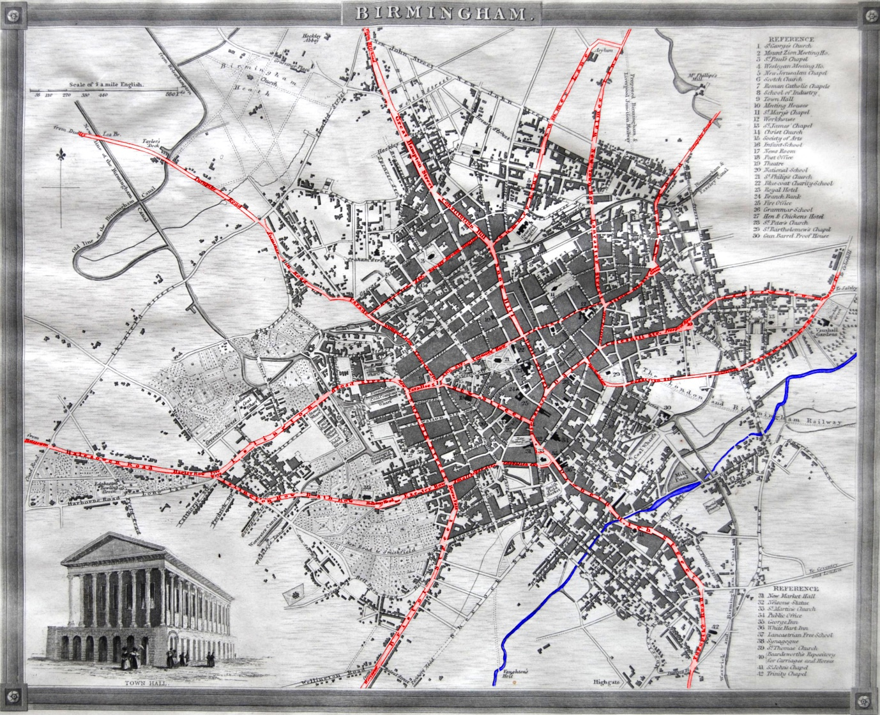

Town Centre Surrounded by: New Street; Ann Street; Colmore Row; Bull Lane; Steelhouse Lane; Stafford Street; Coleshill Street; Dale End ; High Street; New Street
The Nine Spoke Roads
1. Road to/from Warwick & Stratford
High Street; Bull Ring; Digbeth; High Street, Deritend; High Street, Bordesley; Camp Hill &c
2. Road to/from Bromsgrove, Worcester & Bristol
Paradise Street; Suffolk Street; Horse Fair; Bristol Street; &c
3. Road to/from Halesowen, Hagley, Rowley Regis & Stourbridge
Paradise Street; Easy Row; Broad Street; Islington; Five Ways; Hagley Row &c
4. Road to/from Dudley
Congreve Street; Summer Row; Parade; Summer Hill; Spring Hill &c
5. Road to Soho, Walsall, Wolverhampton & Shrewsbury
Snow Hill; Constitution Hill; Great Hampton Row; Hockley Road &c
6. Road to Perry Bridge, Barr Beacon & Stafford
Lancaster Street; New Town Row; Walmer Lane &c
7. Road to Aston, Sutton & Lichfield
Aston Street; Gosta Green; Aston Road &c
8. Road to Coleshill & Atherstone
Coleshill Street; Prospect Row, Ashted Row, Bloomsbury Place &c
9. Road to Cary Field, Vauxhall & Duddeston
Masshouse Lane; Duddeston Street; Curzon Street; St Georges Row, Vauxhall Lane, Bloomsbury Place &c

Divisions & Subdivisions of the Town- see map

Division A Town Centre
Subdivision A1 Bull Lane; Bull Street; High Street &c
Subdivision A2 Dale End, Bull Street; Steelhouse Lane &c

Division B Between spokes 1 & 2
Subdivision B1 inside Smallbrook Street; Edgbaston Street; St Martins Lane
Subdivision B2 from there to River Rea
Subdivision B3 from River Rea out

Division C Between spokes 2 & 3
Subdivision C1 inside Exeter Row; Holloway Head; Bath Row; Islington Row
Subdivision C2 from there out

Division D Between spokes 3 & 4

Division E Between spokes 4 & 5
Subdivision E1 inside Caroline Street; St Pauls Square; Mary Ann Street; Henrietta Street
Subdivision E2 from there out

Division F Between spokes 5 & 6
Subdivision F1 inside Summer Lane; Asylum Road
Subdivision F2 from there out

Division G Between spokes 6 & 7

Division H Between spokes 7 & 8

Division I Between spokes 8 & 9

Division J Between spokes 9 & 1
Subdivision J1 inside River Rea
Subdivision J2 from River Rea out

